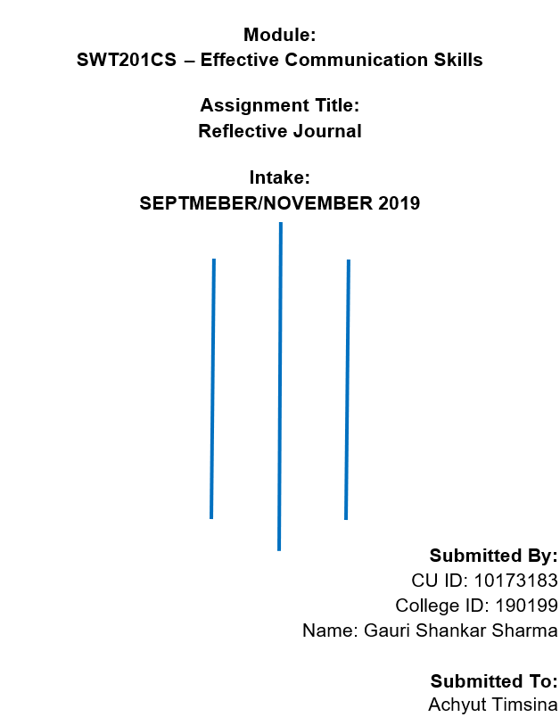

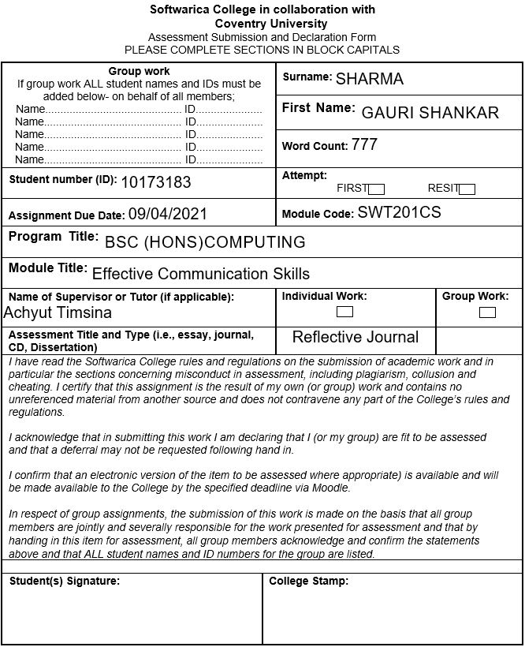

**Personal Revelation**

There are many things related to internal and external communication skills, personality reflection, and positivity that we discussed and practiced through the Effective Communication Skills course topics in this semester. But the most effective topic that changes my visualization on communication was Emotional Intelligence (EI). I had no idea about EI before. After knowing it I realize that EI is another talent that is also as important as IQ to reflect our personality and I had very low EI.

I was trying to ask the teacher some questions about the weekly assignment at the end of the online class. My English pronunciation was very bad and my talking was a little bit shaky and the teacher also didn’t understand the questions properly. So, he told me to ask him again and I hardly repeated my questions. I even couldn’t admit my confusion properly. I was also a bit nervous while showing the classwork to the teacher in front of the other students in one of the online classes before. I was disappointed and a little bit frustrated because I couldn’t communicate and express myself properly and I realized that I should have been prepared before asking the questions. I learned that assertive communication is very important while dealing with a person to get desired outcomes and I was not assertive at all. Understanding, confidence, and nervousness are also the source behind communication skills. If a person has a clear understanding but he is nervous, then the communication will be never better. So, for better communication confidence is a compulsory factor. One of my friends come to me while I was taking a quick look at the assignment of Algorithm and Data Structure and he asked me to give him the coding of the assignment tasks when I complete them. I did not like the way he asked me for help and I refused to give him the coding. I told him that I will explain and clarify the questions and give all the solutions of the questions but I would not give the coding because it will be copy and paste. Then he also agreed with my statement. Sometimes we get into some kind of situation in which we have to deny the incoming request otherwise it will affect us badly or make a loss in the future. Saying “no” to some else’s request in a good way is very challenging. We have to be very careful with our words. We have to provide a clear understanding of why we refuse the request.

I was reserved, less confident, weak on expressive things, and a bit shy. I was not able to communicate as properly as I want even if I have a clear understanding because of my nervousness. From the similar events as explained in the above paragraph, I was able to improve myself. Now I can speak in front of the class without hesitating and choking. I gain patients inside myself and I don’t take many worries. My conversations were aggressive before and now I can establish a trustful and meaningful conversation with anyone even if I don’t know the person. I used to give unnecessary information while talking but now I have managed to filter my content while talking. I am more assertive now. I can refuse anyone’s request positively if I have to. I have increased self-motivation and I have managed to keep positivity during the communication. Sometimes I used to get confused during the conversion but I am very specific and straightforward now. I had very low EI before and now I have improved my EI a little bit. I will be improving my EI as much as I can in the coming days so that I can reflect on a better personality while communicating with people. It will help me to build a better career in the future. I am also following some NLP techniques to develop personal areas. I am trying to create some anchors while expressing my emotions. Before starting a conversation with a person that I have never talked to, I mirror the person’s behavior to communicate in his way so that I can build a trustable connection. I care about eye movement while talking to understand the person more deeply. Sometimes I reframe my thoughts if I failed to do something or got in a bad situation to stay away from negative thoughts. I disassociate the events of my past from my mind which makes me down and feel sad when remembering them. I always try to stay positive and happy so that there will be no distractions and failures on the way to my career.